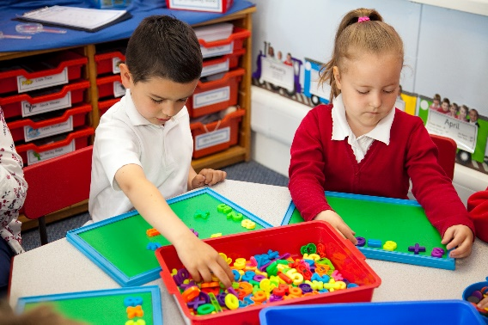

|  |
| --- |
| Overview |

Text here

The focus for Early Years (EY) work has progressed to support practitioners at each stage of their development. For practitioners who are new to EY, or with limited EY maths experience and training, there is a project that explores key concepts in early mathematical development and effective pedagogies that support EY mathematics learning. For experienced EY practitioners (3+ years) looking to develop aspects of their practice, there are focused projects that will enhance practice on a particular theme in EY maths. These projects will enable participants to review practice, consider current research and develop their leadership capacity.

**Who is this for?**

School based practitioners leading the planning and provision of mathematics in Early Years (i.e. Nursery and/or Reception), particularly those who are not EYFS specialists

**What is involved?**

* 3 days of workshops with other practitioners on the programme
* Independent study and setting-based work including gap tasks and evaluation
* Online discussion as part of a professional community
* Support and mentoring from Work Group Lead

Intended Outcomes

For teachers to develop planning and provision for EY mathematics across their environment, using the pedagogies of EY best practice, to ensure that all children are provided with access to deep mathematical learning across the environment. For children to access a developed use of structured representations so that pupils are supported with fully exploring (and/or articulating) their mathematical ideas. We will also examine the importance of promoting a positive attitude to maths to encourage children’s willingness to ‘have a go’.

**Early Years**

**The wider context**

Collectively, the network of Maths Hubs across England work on projects around national maths education priority areas. One of those priorities requires Maths Hubs to provide high quality training in EY maths in order to improve children’s understanding of maths at a young age, with a particular focus on practitioners’ subject knowledge. Each Maths Hub participating in a national project runs a local Work Group, where teachers come together over a period of time to work on areas defined by the project. All Work Groups are subject to a common evaluation process, which collectively provides a body of evidence on the project’s outcomes. So, your participation in this Work Group will contribute to your own professional leaning, and that of your school colleagues, as well as making a contribution to the improvement of maths education at a national level. This Work Group extends work started in the 2017-2018 national project of the same name.

**Who is leading the Work Group?**

This Work Group will be led by Fiona Wood

Fiona is an NCETM PD Accredited lead and experienced Primary Maths Subject leader, with MaST qualification. She has been part of the national working party to develop this EYFS Development work group.

Fiona was successful in being selected as one of the twelve Primary Maths Specialist Teachers for Salop and Herefordshire Maths Hub. She has undertaken extensive Primary Maths research of different educational systems, including working collaboratively with and hosting teachers from Shanghai.

Fiona is an NCETM PD Accredited lead and experienced Primary Maths Subject leader, with MaST qualification. She has been part of the national working party to develop this EYFS Development work group.

Fiona was successful in being selected as one of the twelve Primary Maths Specialist Teachers for Salop and Herefordshire Maths Hub. She has undertaken extensive Primary Maths research of different educational systems, including working collaboratively with and hosting teachers from Shanghai.

**Funding**

This Work Group is free to participants

**Expectations of participants and their settings**

All participants must be able and willing to commit to participate fully in all elements of the programme.

The participant’s school/setting must have the capacity and commitment to support them throughout the programme.

**If you’re interested, what next?**

Session 1: 08/03/19

Session 2: 29/03/19

Session 3: 07/06/19

10:00am to 3:00pm on all days.

Venue: Slade Primary School (B23 7PX)

To register, please go to [www.centralmathshub.com/EYFS](http://www.centralmathshub.com/EYFS)